1. **TRELLO_ACTION_GET_BOARD_BY_ID_ACTION**

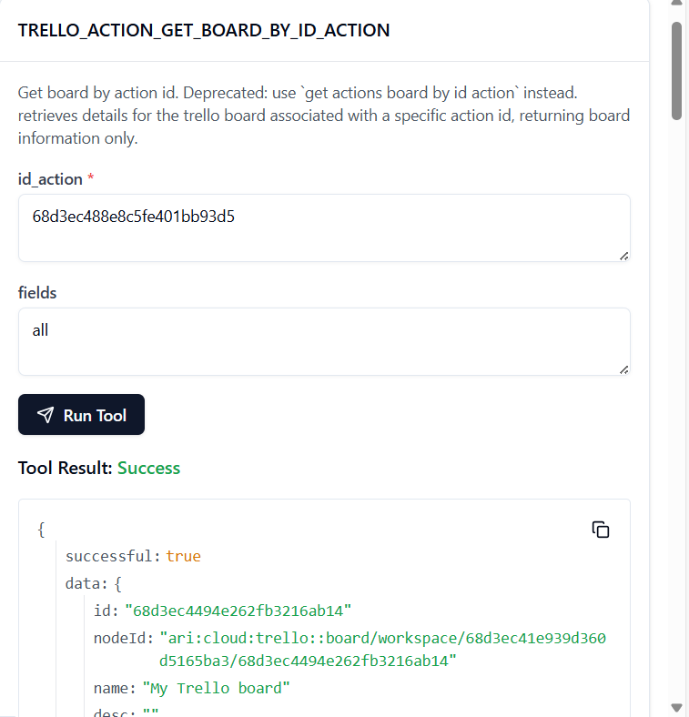

TO GET THE BOARD ID:

<https://api.trello.com/1/boards/68d3ec4494e262fb3216ab14?key=0e25f87141aa66e3d5d9116f606c989d&token=ATTA703ac75455c2e1835e473d2868aededa8de3f9bce180293b1331718b048edef4752AA41F>

TO GET THE ACTION ID:

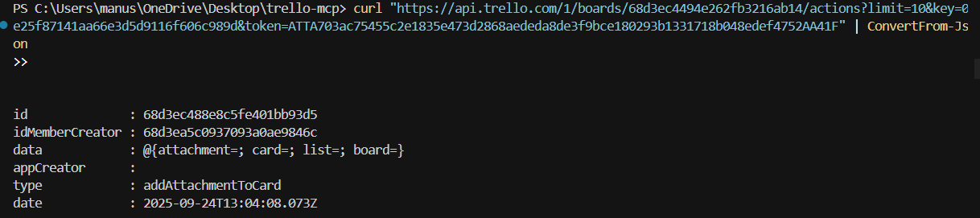

2. **TRELLO_ACTION_GET_BY_ID**

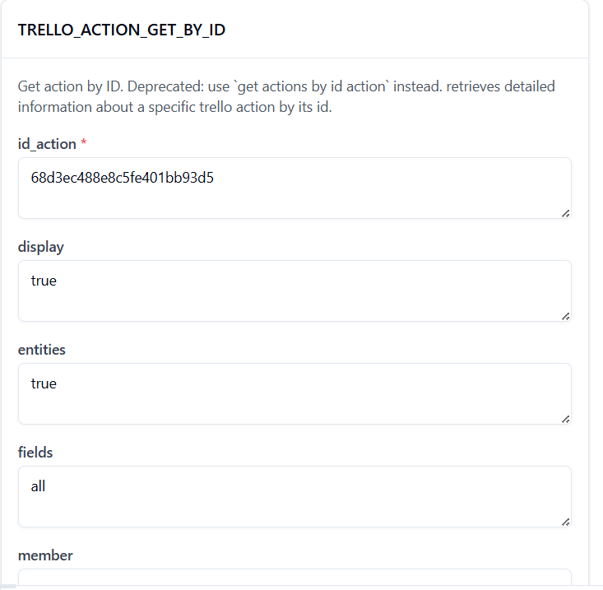

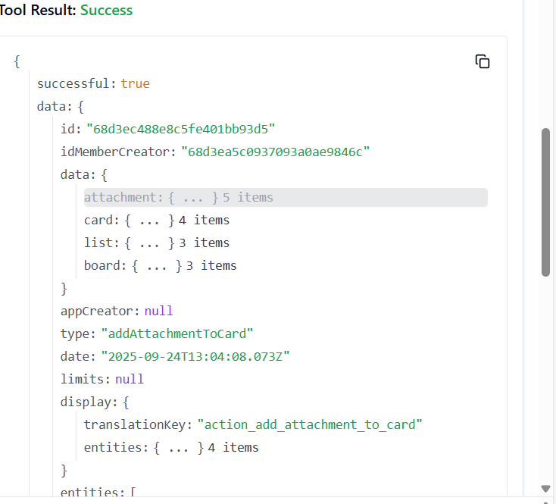

3. **TRELLO_ACTION_GET_LIST_BY_ID_ACTION**

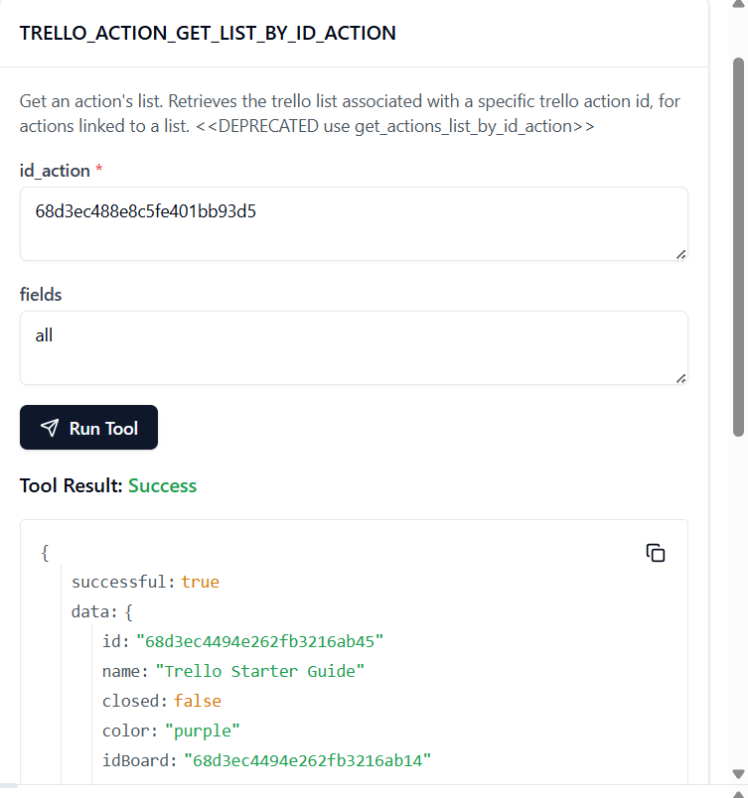

4. **TRELLO_ADD_BOARDS**

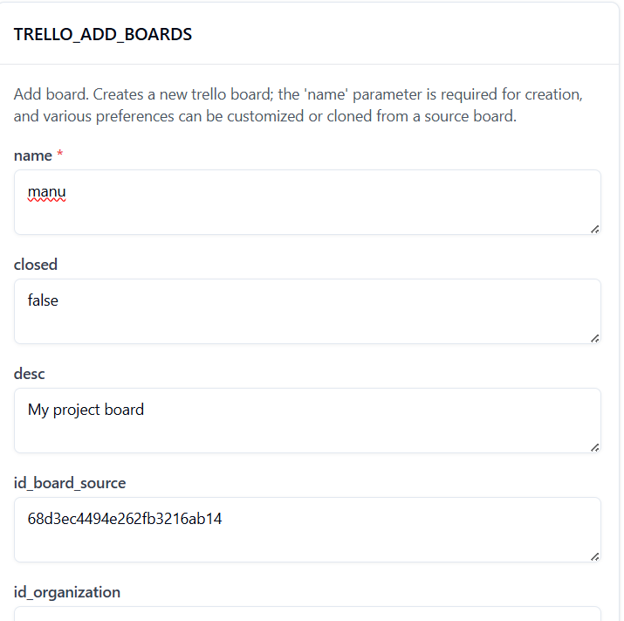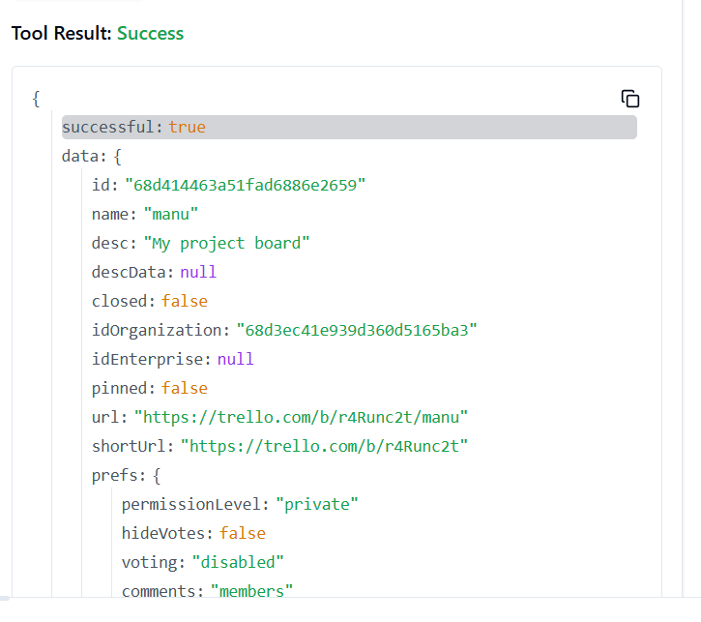

5. **TRELLO_ADD_BOARDS_CALENDAR_KEY_GENERATE_BY_ID_BOARD**

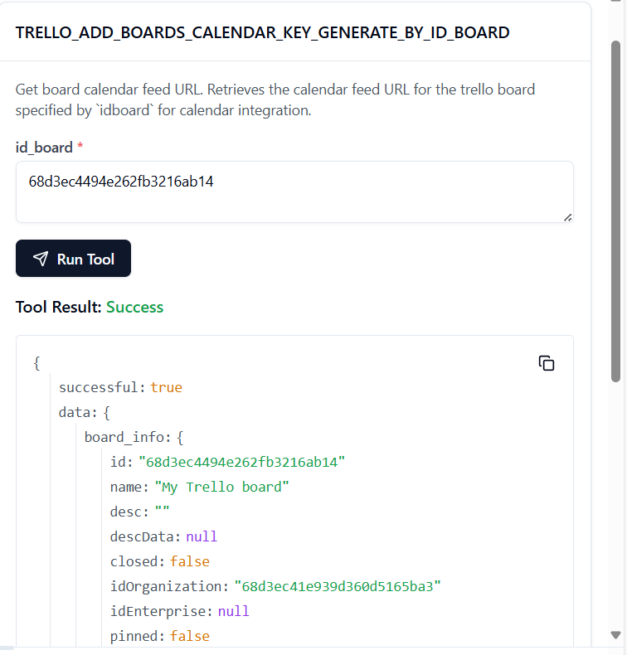

6. **TRELLO_ADD_BOARDS_EMAIL_KEY_GENERATE_BY_ID_BOARD**

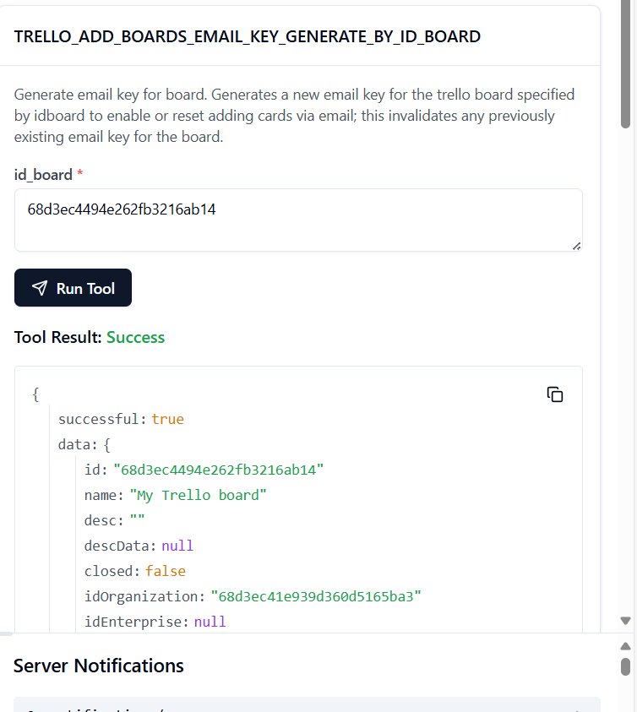

7. **TRELLO_ADD_BOARDS_LABELS_BY_ID_BOARD**

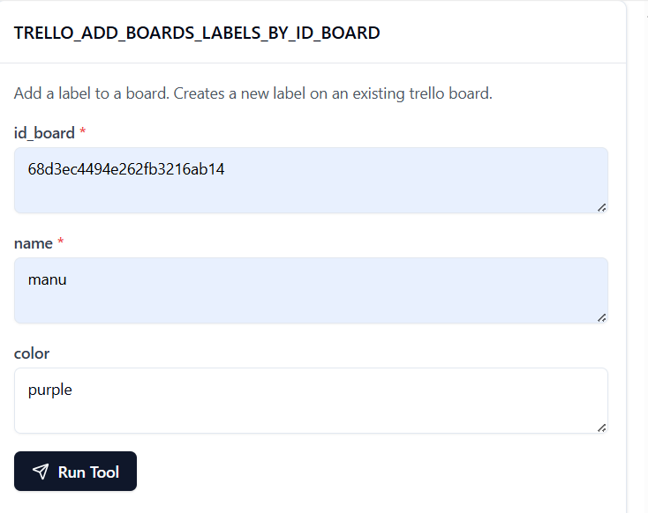

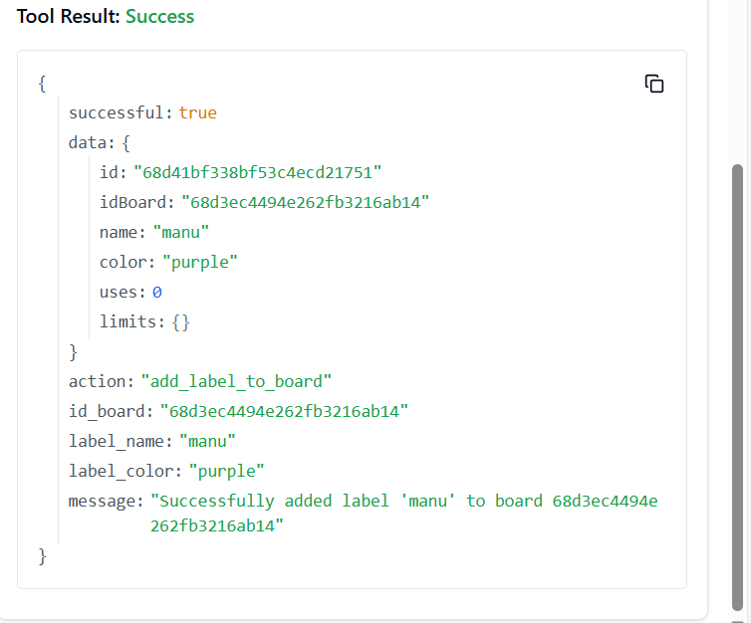

8. **TRELLO_ADD_BOARDS_LISTS_BY_ID_BOARD**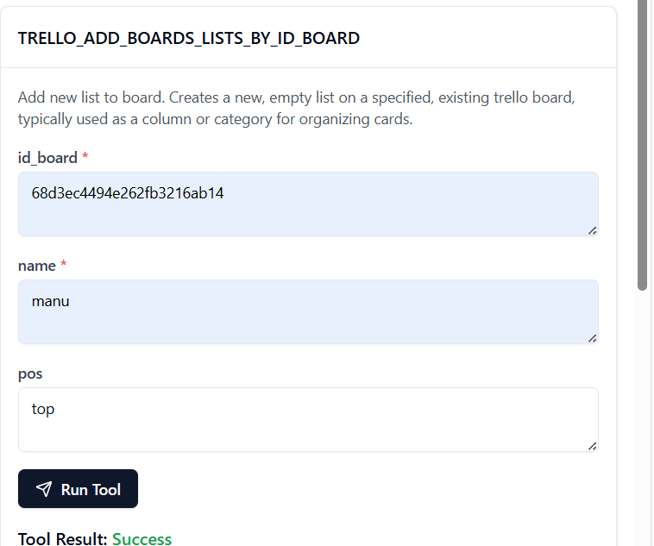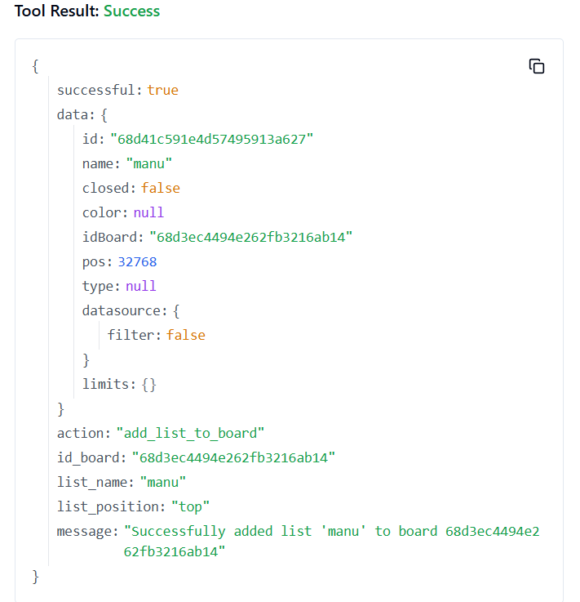

**9. TRELLO_ADD_BOARDS_MARK_AS_VIEWED_BY_ID_BOARD**

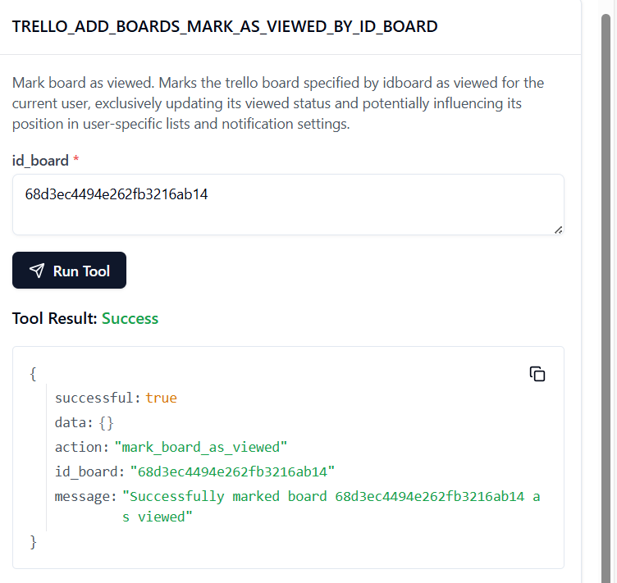

**10. TRELLO_ADD_BOARDS_POWER_UPS_BY_ID_BOARD**

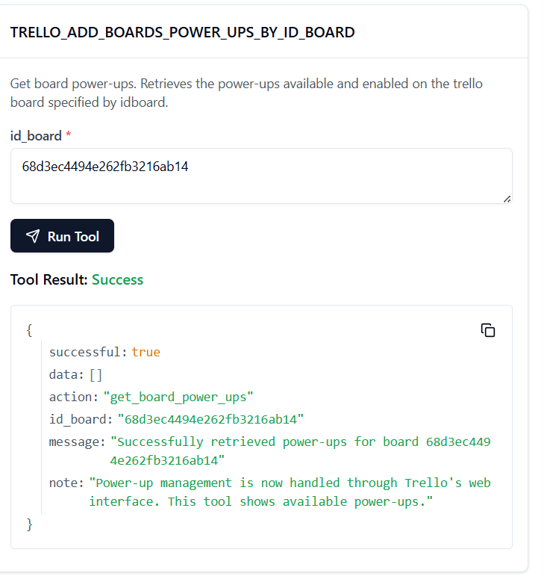

**11. TRELLO_ADD_CARDS**

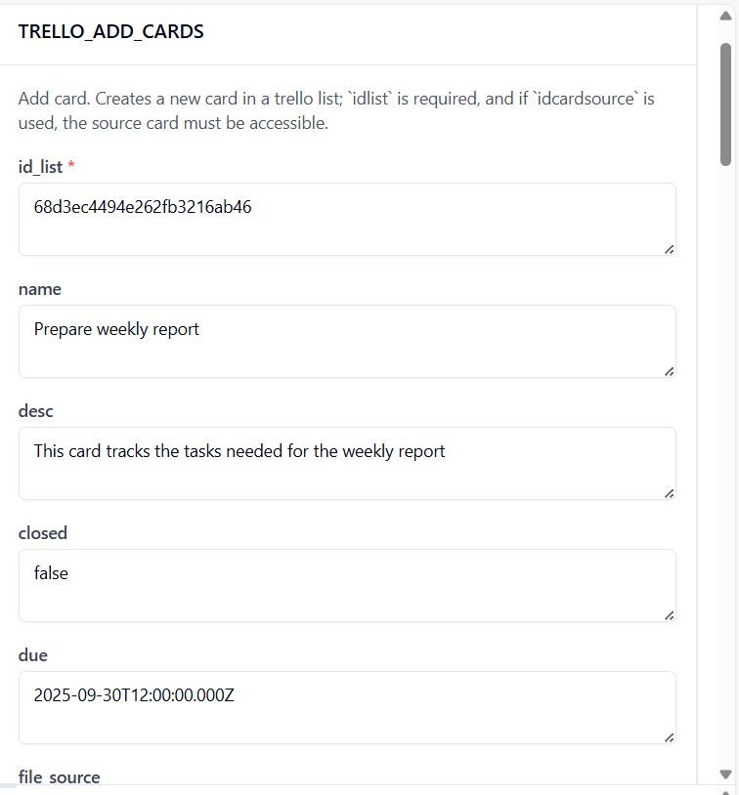

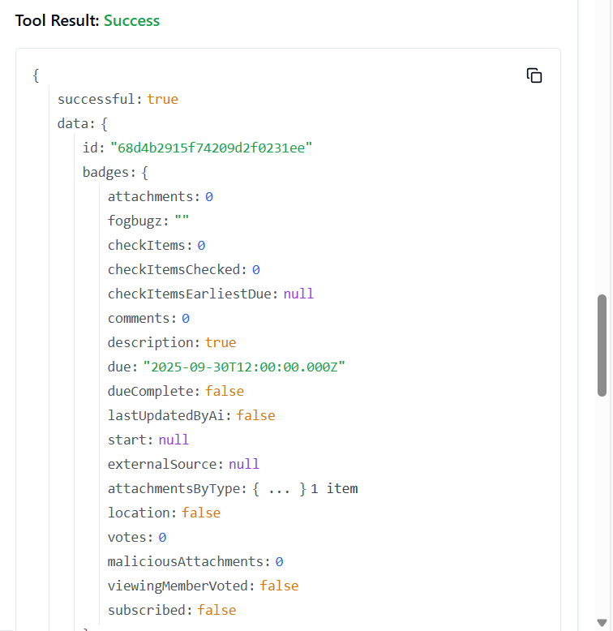

12. **TRELLO_GET_BOARDS_CARDS_BY_ID_BOARD**

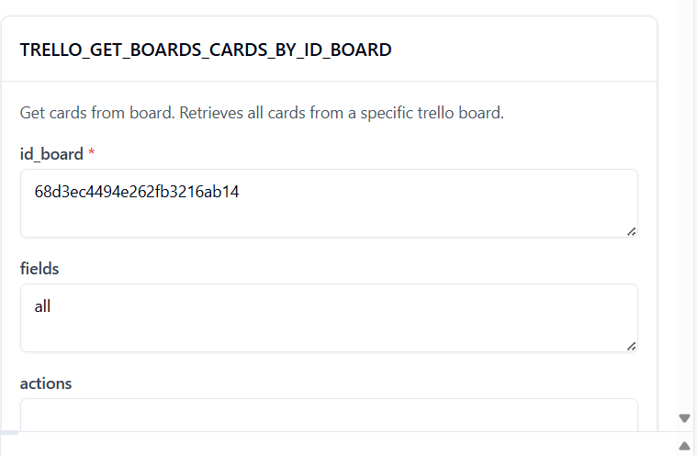

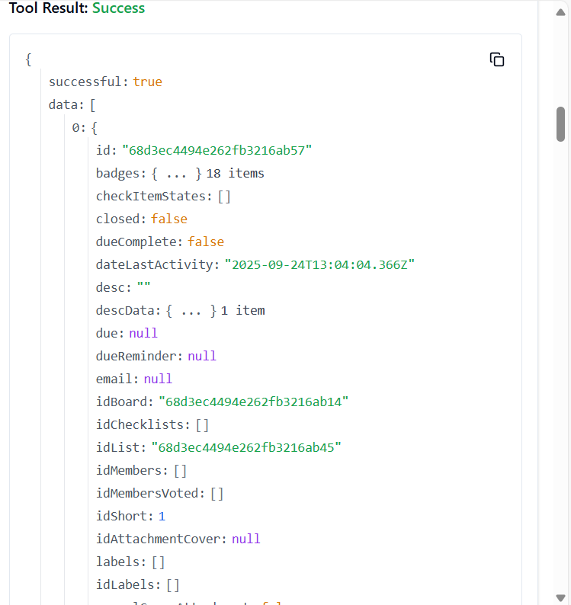

13. **TRELLO_ADD_CARDS_CHECKLISTS_BY_ID_CARD**

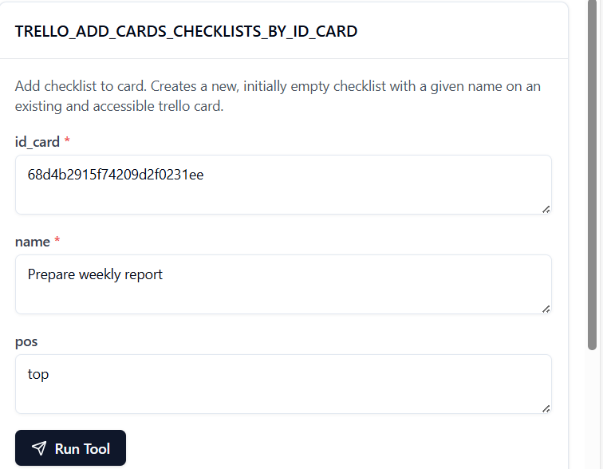

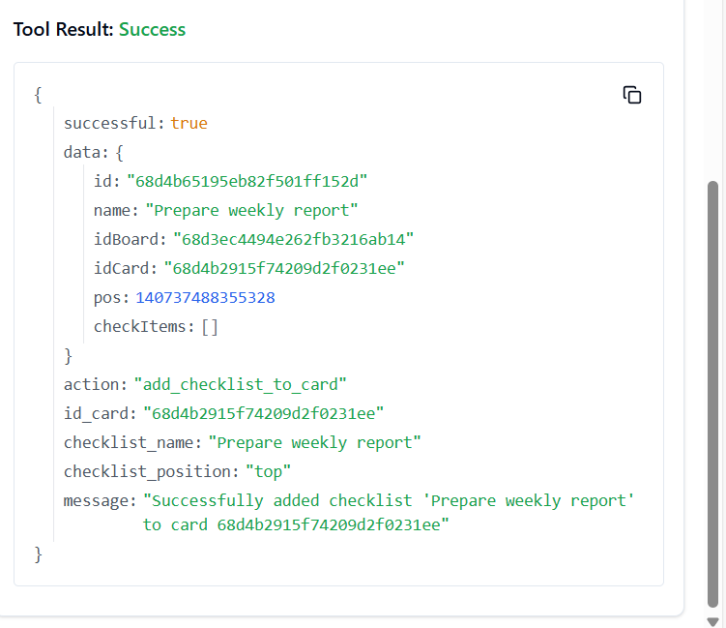

14. **TRELLO_ADD_CARDS_ACTIONS_COMMENTS_BY_ID_CARD**



15. **TRELLO_ADD_CARDS_CHECKLIST_CHECK_ITEM_BY_ID_CARD_BY_ID_CHECKLIST**

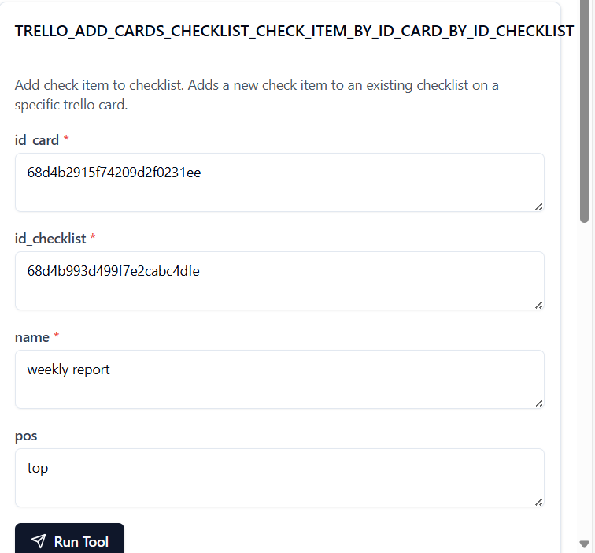

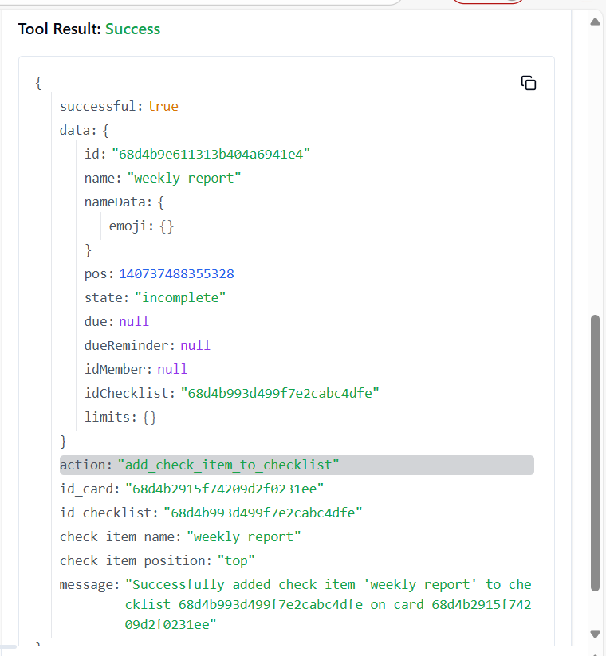

16. **TRELLO_ADD_CARDS_ID_LABELS_BY_ID_CARD**

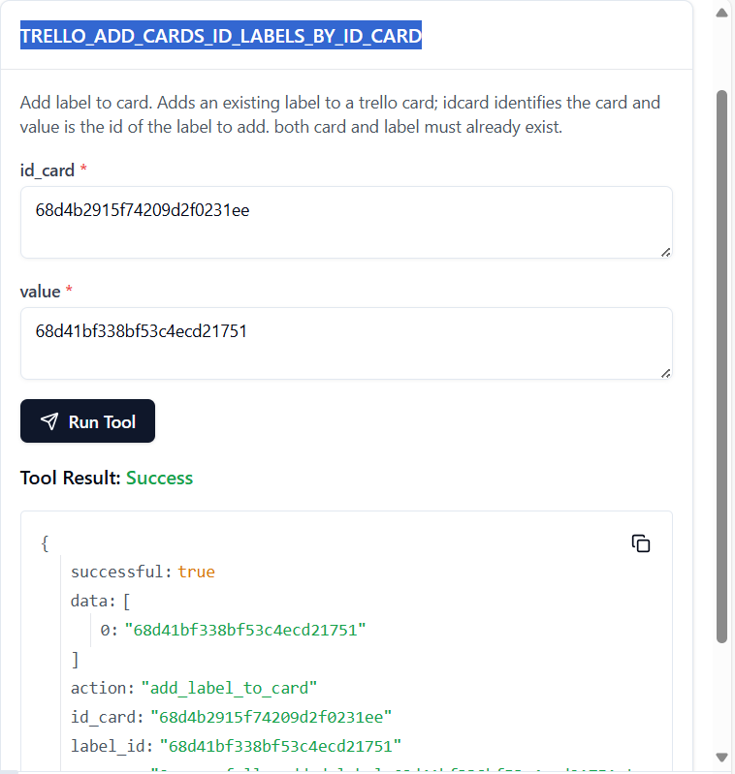

TO GET LABLE: curl -X GET "https://api.trello.com/1/boards/68d3ec4494e262fb3216ab14/labels?key=0e25f87141aa66e3d5d9116f606c989d&token=ATTA65c191642e05fdfd6583611281180e46fcf76d9a504d4f5dc84bcdc175823b26A1261C34"

17. **TRELLO_ADD_CARDS_ID_MEMBERS_BY_ID_CARD**



TO GET THE MEMBER ID: curl -X GET <https://api.trello.com/1/boards/68d3ec4494e262fb3216ab14/members?key=0e25f87141aa66e3d5d9116f606c989d&token=ATTA65c191642e05fdfd6583611281180e46fcf76d9a504d4f5dc84bcdc175823b26A1261C34>

18. **TRELLO_ADD_CARDS_LABELS_BY_ID_CARD**

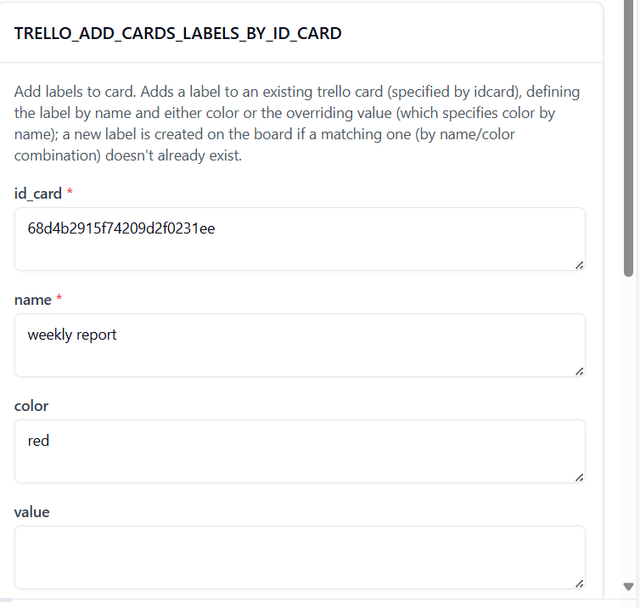

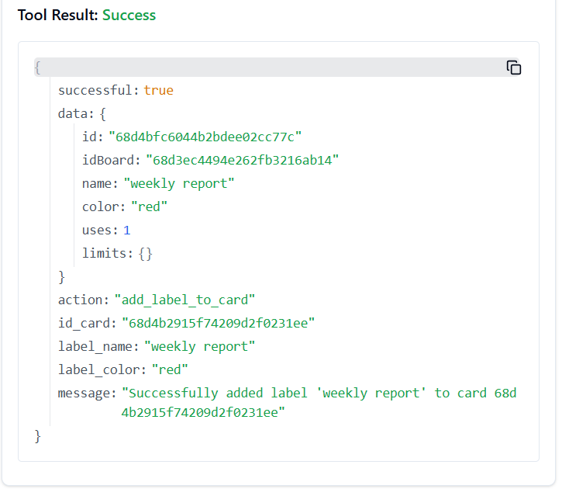

19. **TRELLO_ADD_CARDS_STICKERS_BY_ID_CARD**

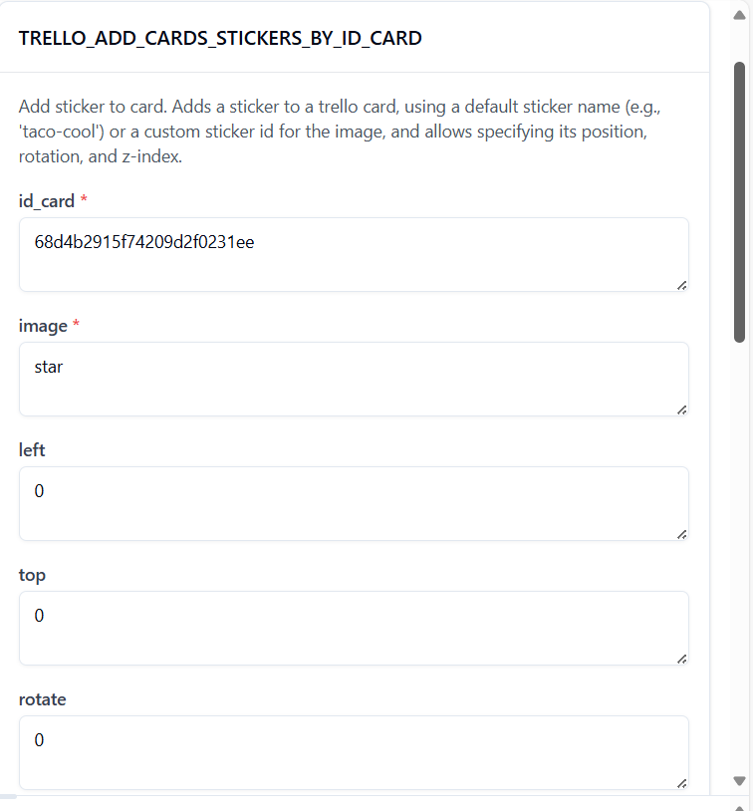

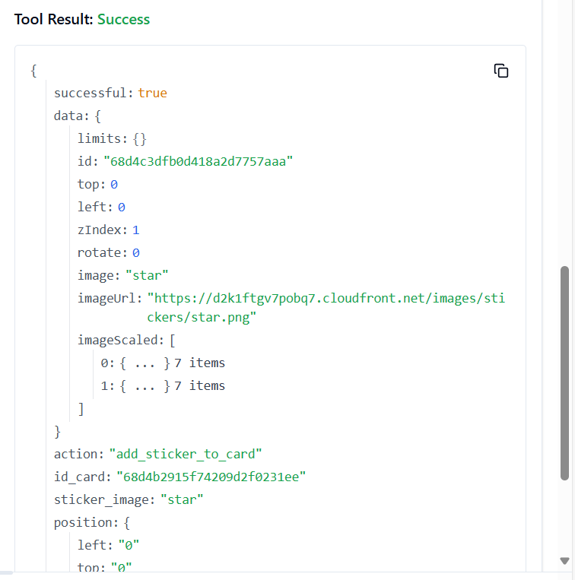

20. **TRELLO_ADD_CHECKLISTS**

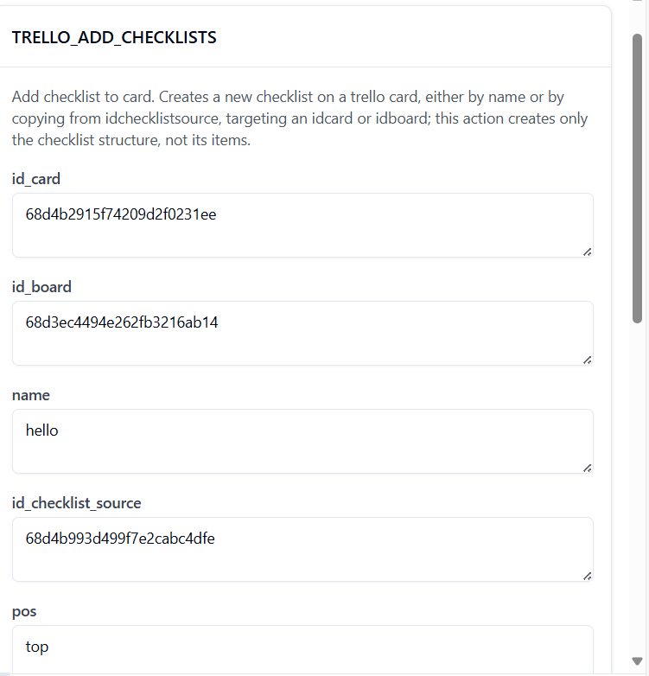

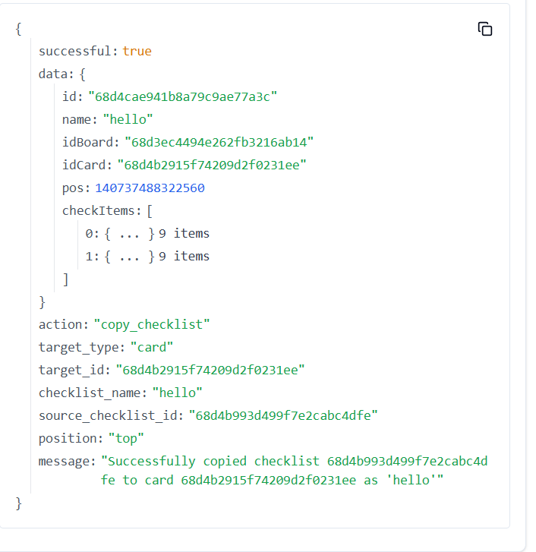

21. **TRELLO_ADD_CHECKLISTS_CHECK_ITEMS_BY_ID_CHECKLIST**

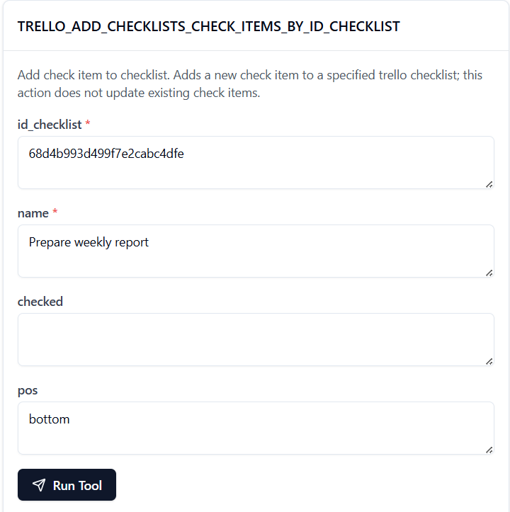

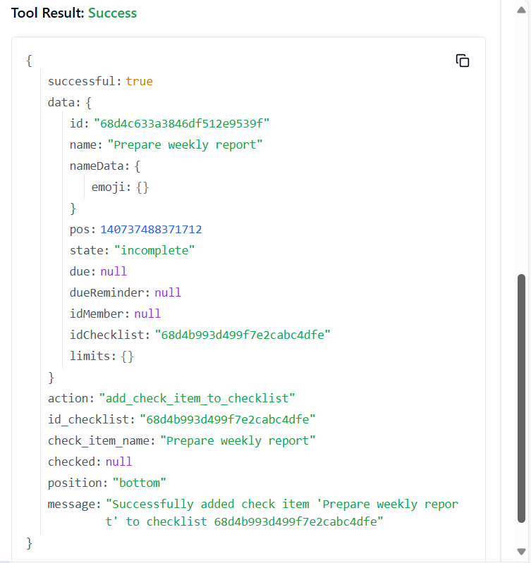

22. **TRELLO_ADD_LABELS**

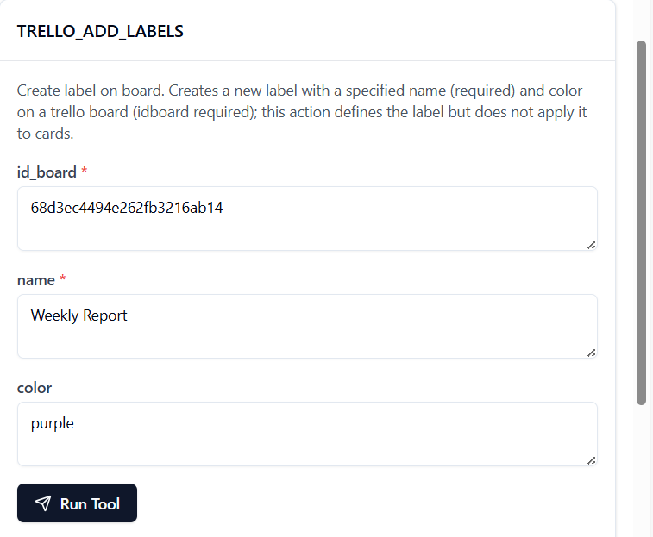

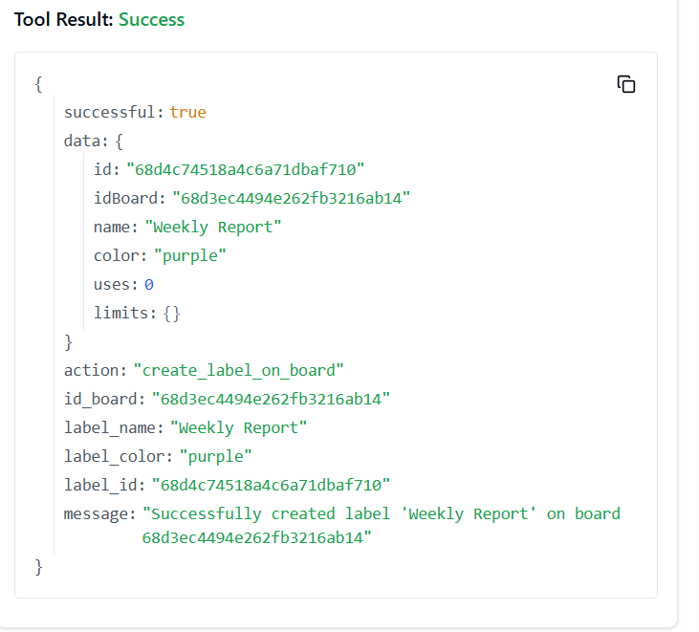

23. **TRELLO_ADD_LISTS**





24. **TRELLO_ADD_LISTS_ARCHIVE_ALL_CARDS_BY_ID_LIST**



25. **TRELLO_ADD_LISTS_CARDS_BY_ID_LIST**

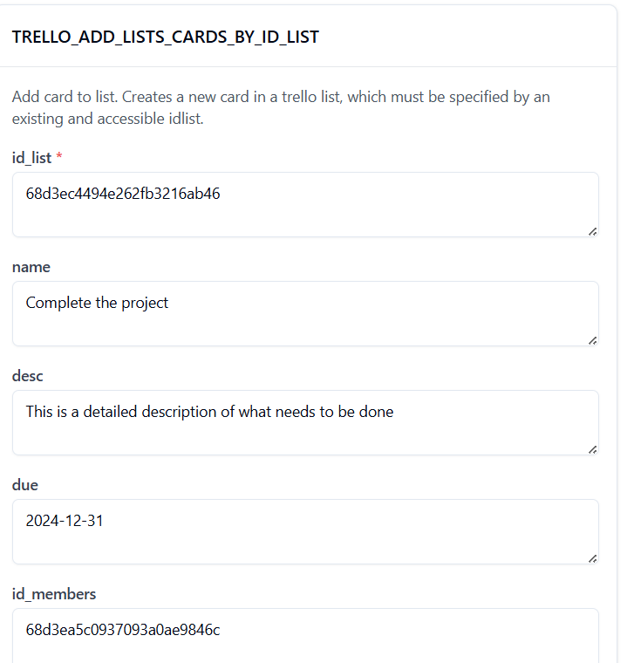

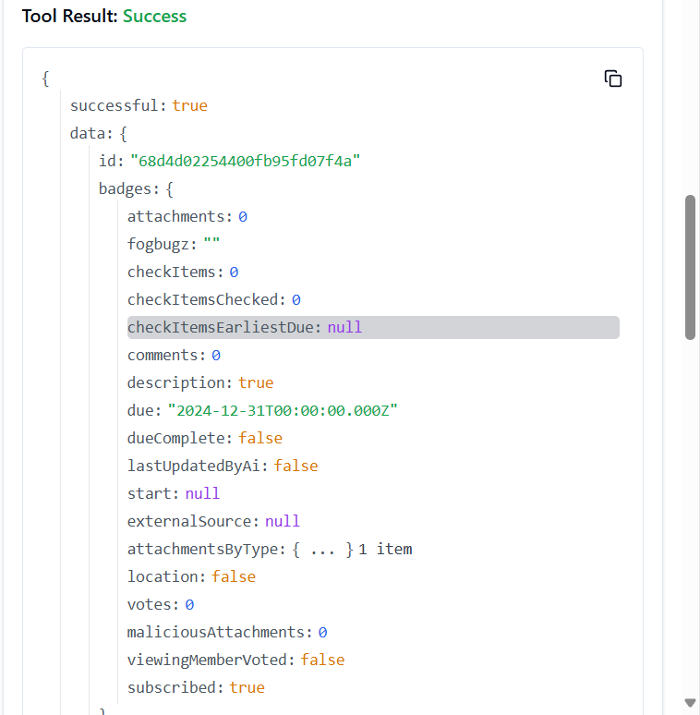

26. **TRELLO_ADD_LISTS_MOVE_ALL_CARDS_BY_ID_LIST**

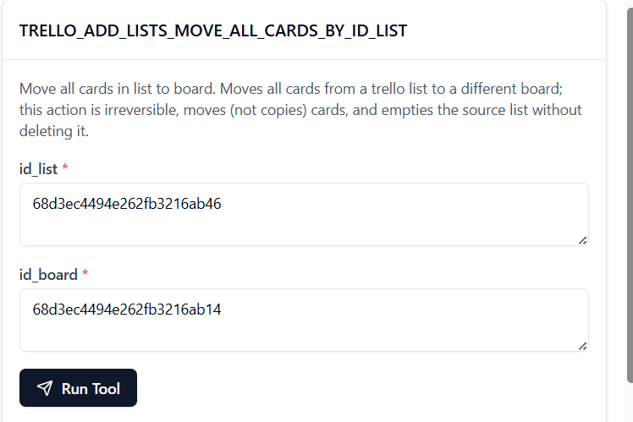

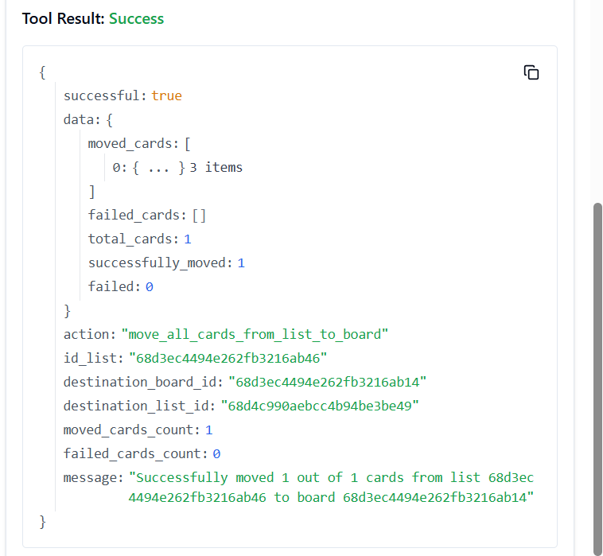

27. **TRELLO_ADD_MEMBERS_BOARD_STARS_BY_ID_MEMBER**

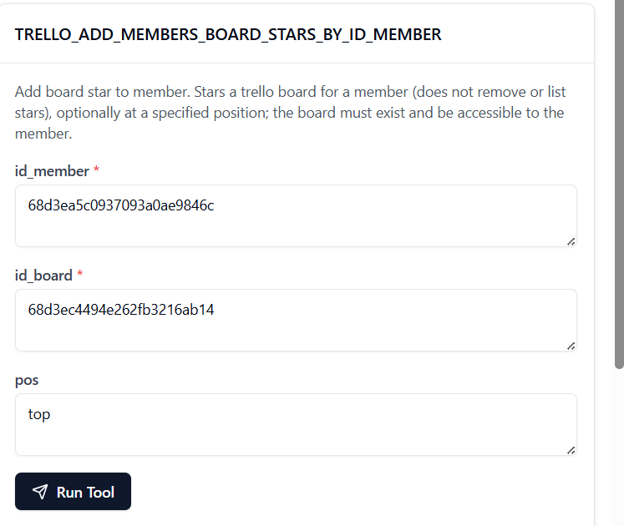

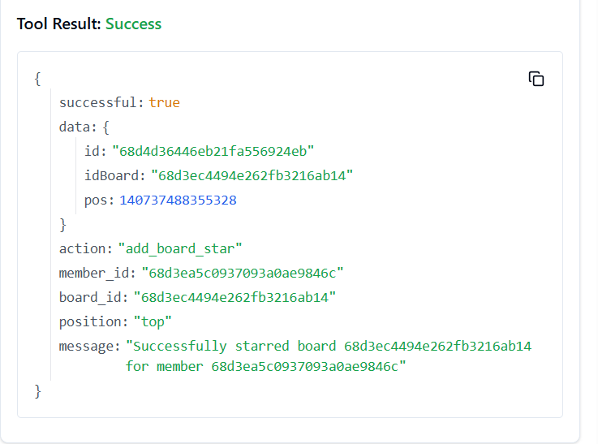

28. **TRELLO_ADD_MEMBERS_SAVED_SEARCHES_BY_ID_MEMBER**

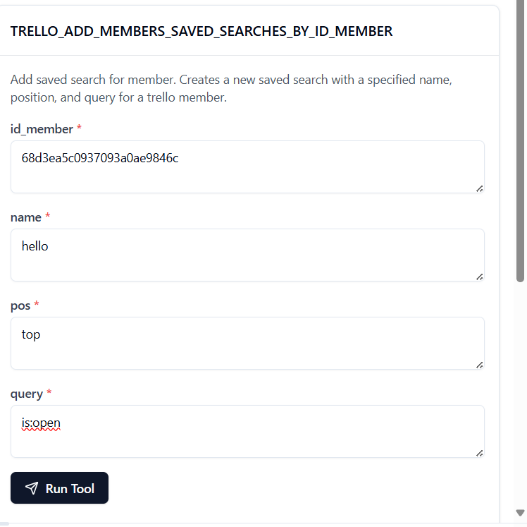

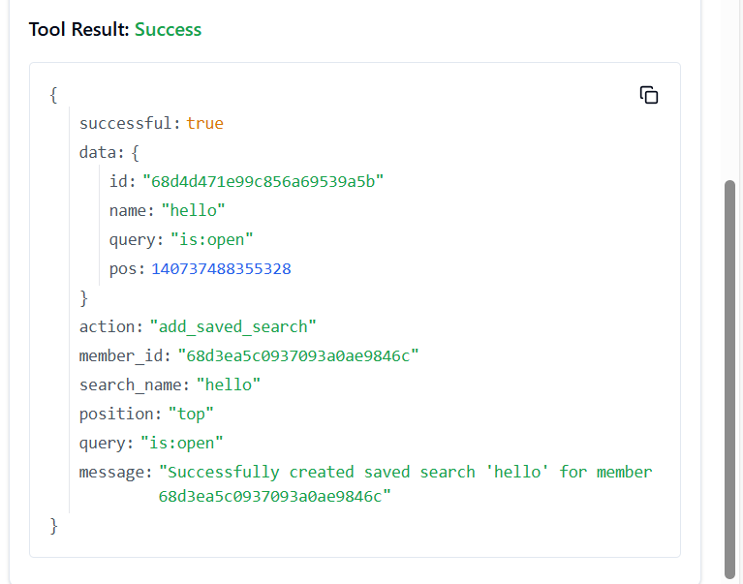

29. **TRELLO_ADD_NOTIFICATIONS_ALL_READ**

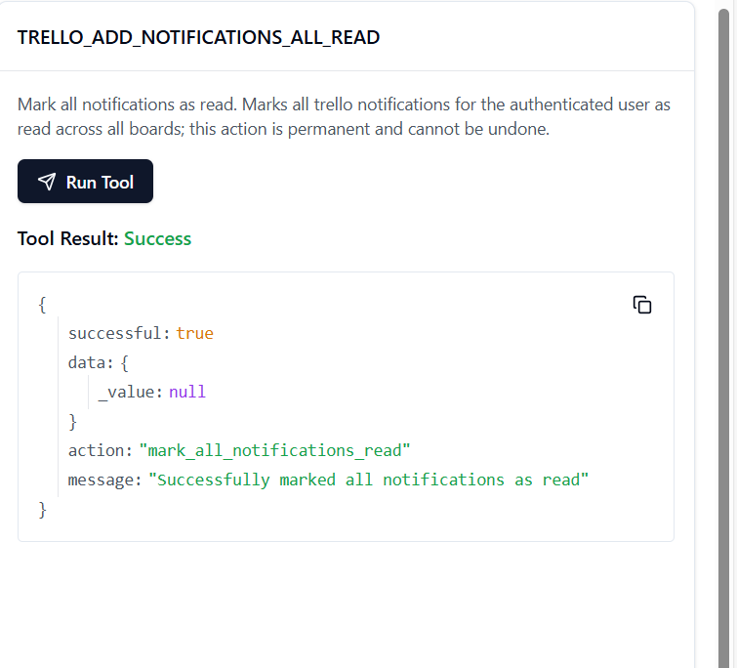

30. **TRELLO_ADD_ORGANIZATIONS**

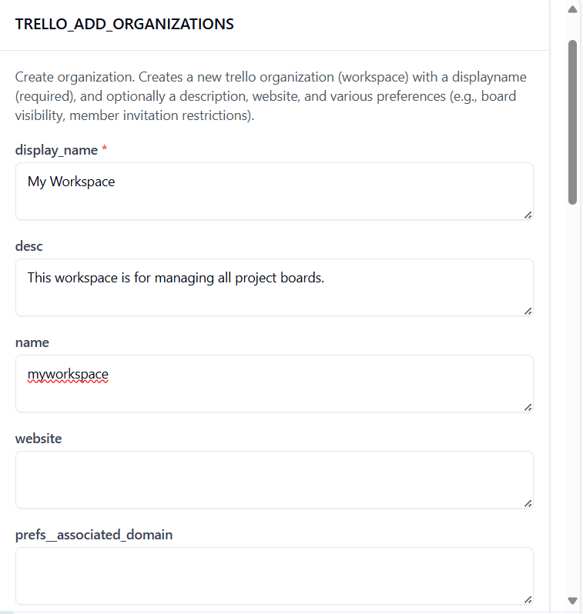

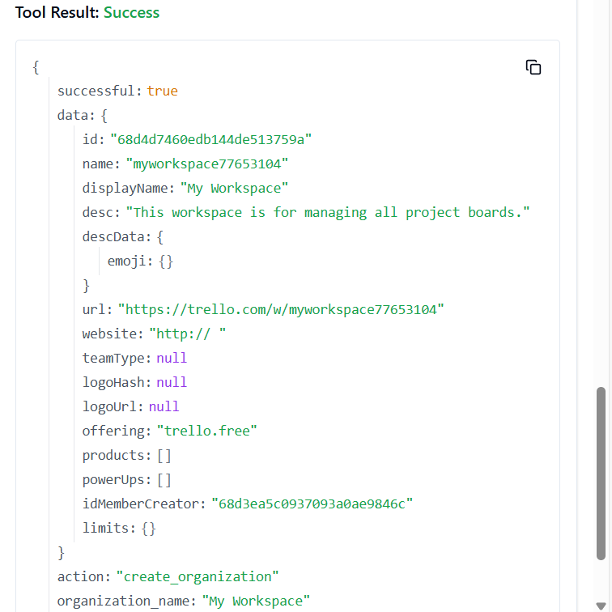

31. **TRELLO_BOARD_CREATE_BOARD**

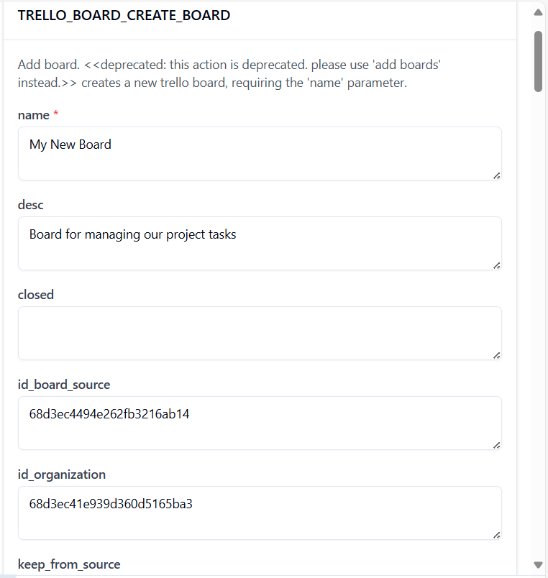

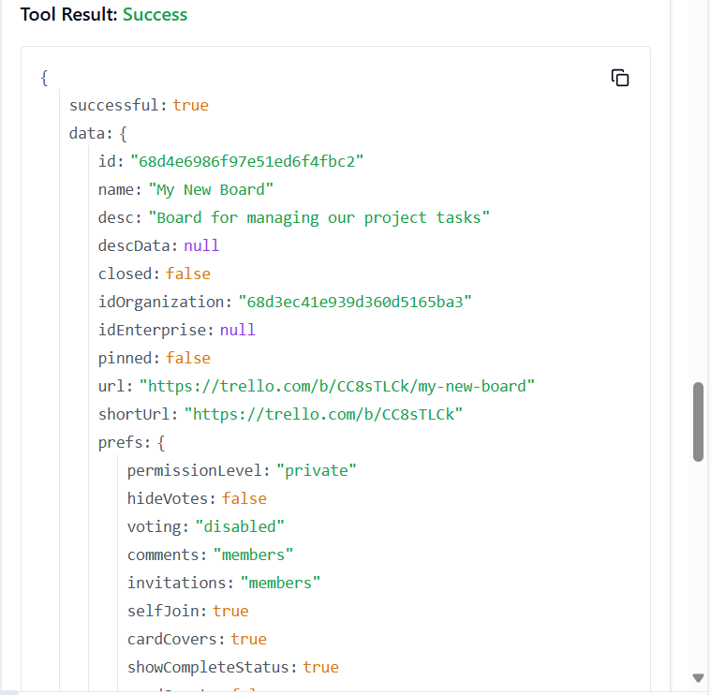

32. **TRELLO_BOARD_FILTER_CARDS_BY_ID_BOARD**

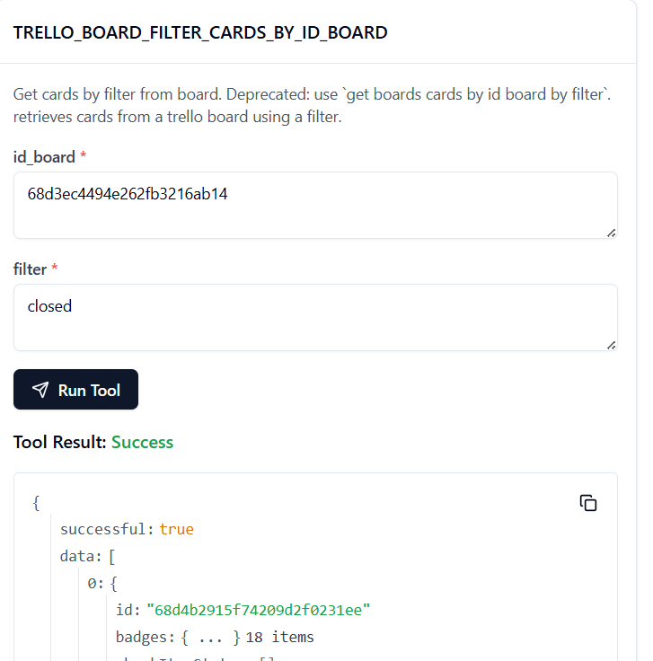

33. **TRELLO_BOARD_GET_LISTS_BY_ID_BOARD**

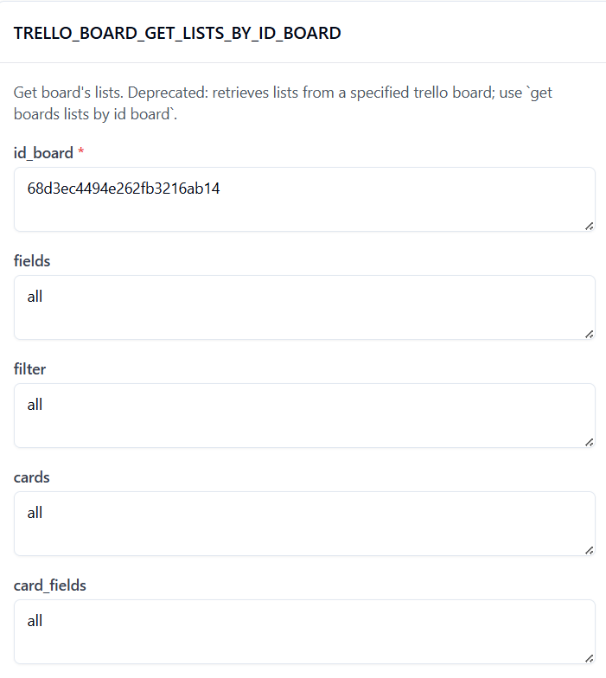

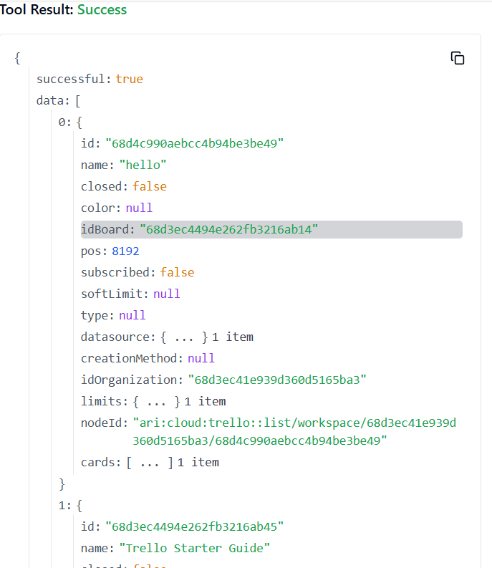

34. **TRELLO_CARD_GET_BY_ID_FIELD**

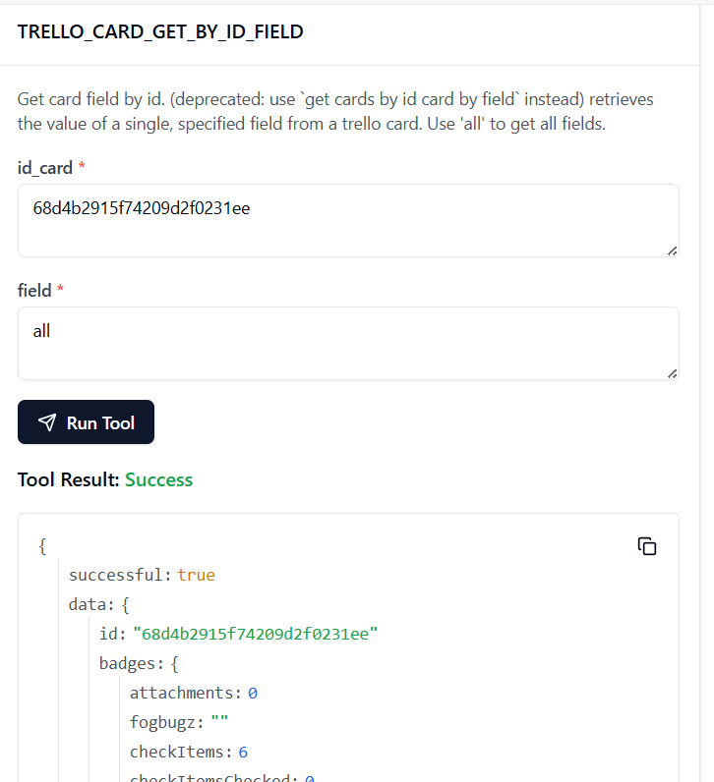

35. **TRELLO_CARD_UPDATE_ID_LIST_BY_ID_CARD**

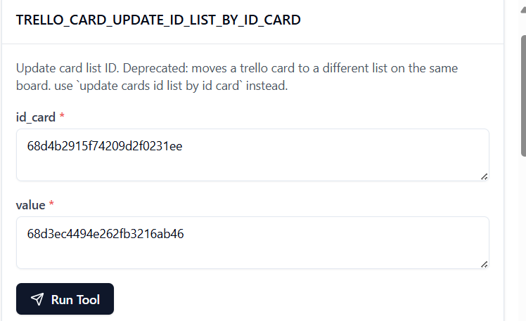

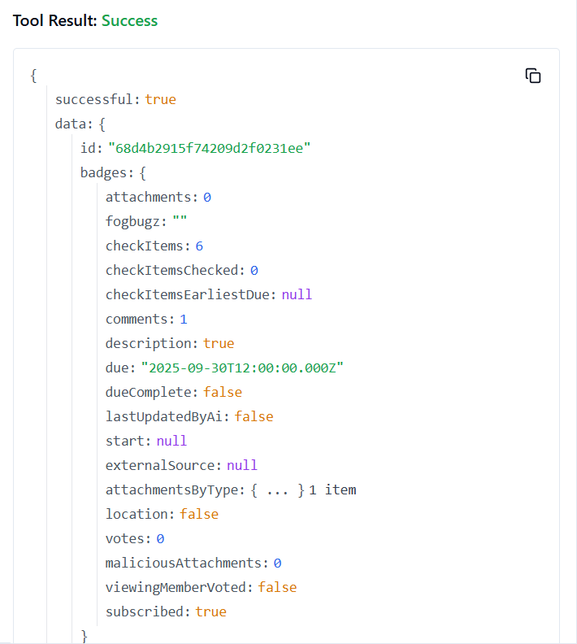

36. **TRELLO_CARD_UPDATE_BY_ID_CARD**

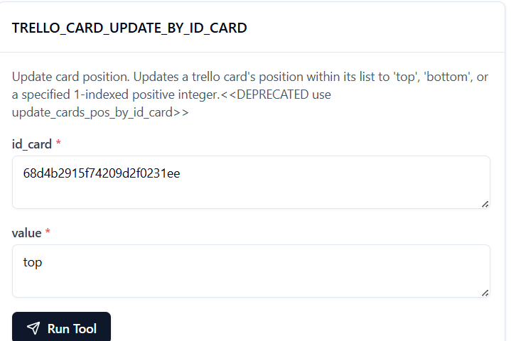

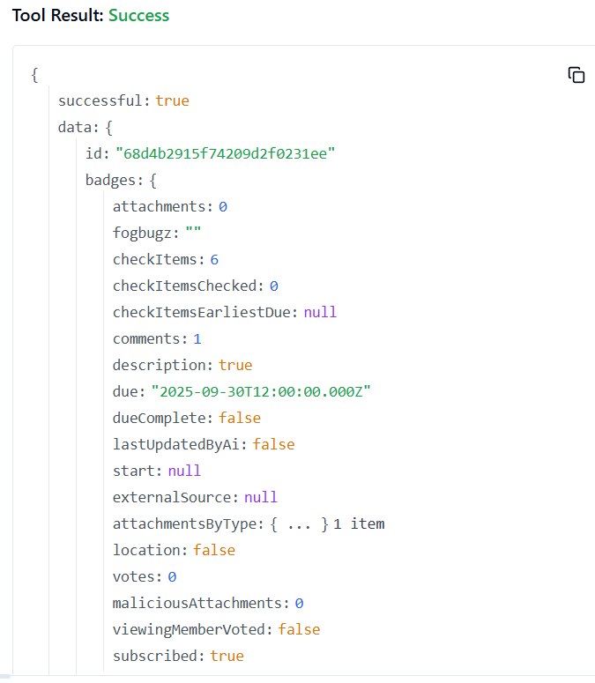

37. **TRELLO_CONVERT_CHECKLIST_ITEM_TO_CARD**

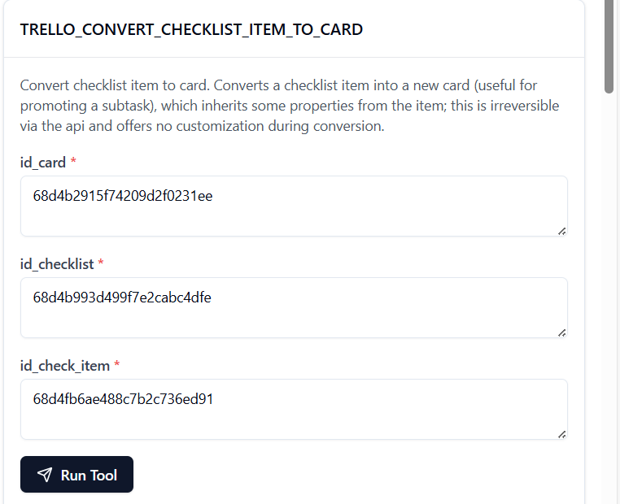

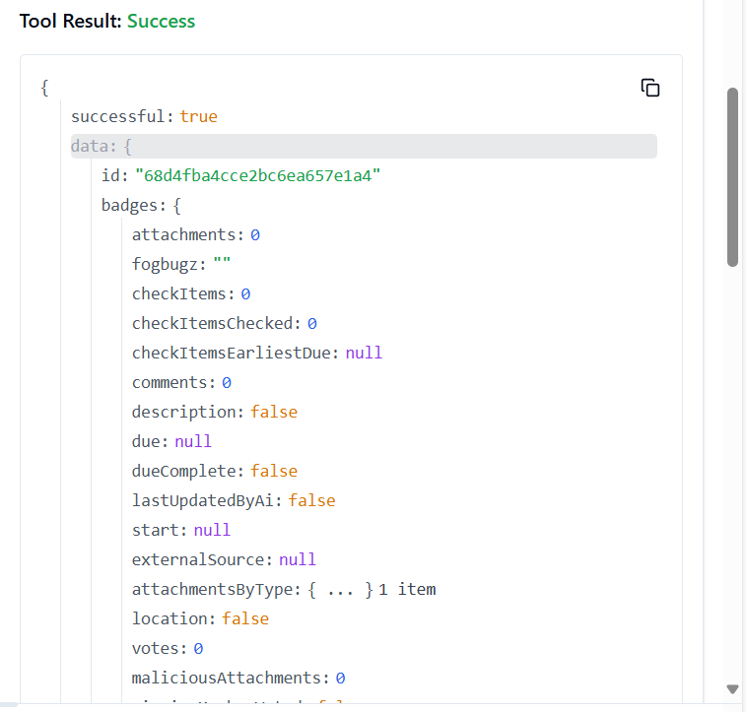

38. **TRELLO_GET_ACTIONS_BOARD_BY_ID_ACTION**

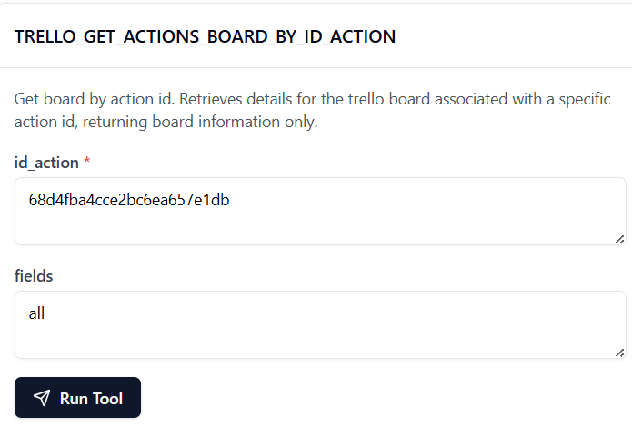

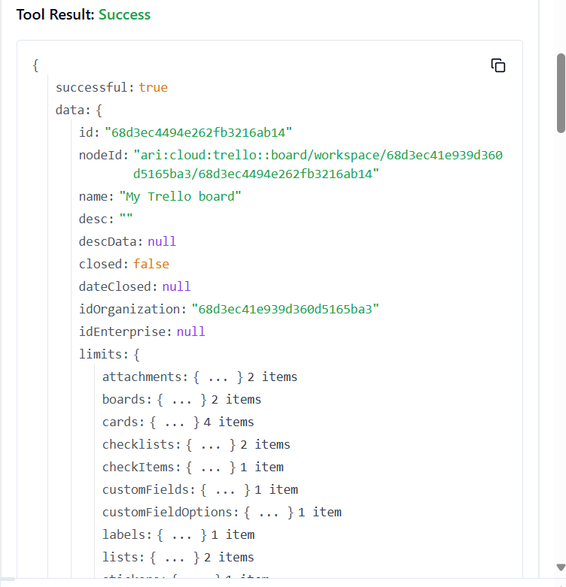

39. **TRELLO_GET_ACTIONS_BOARD_BY_ID_ACTION_BY_FIELD**

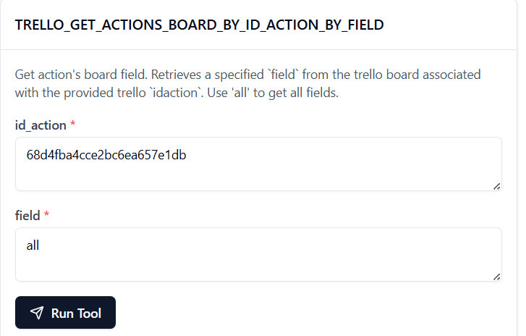

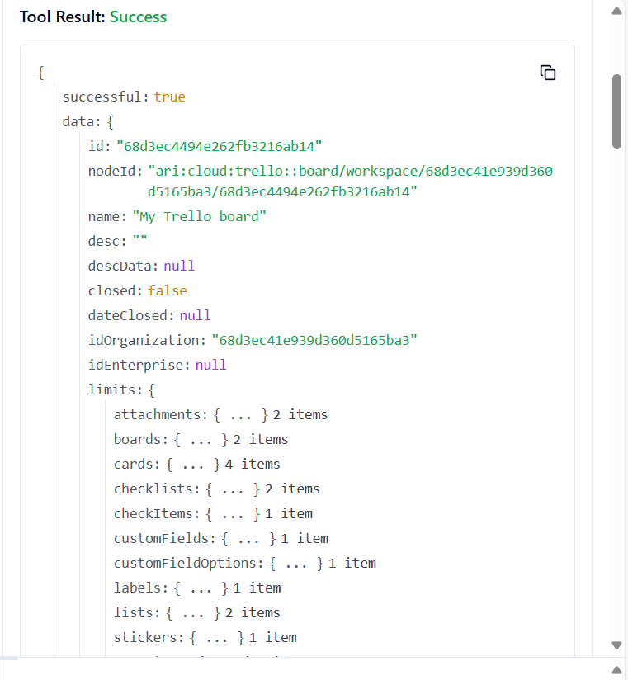

40. **TRELLO_GET_ACTIONS_BY_ID_ACTION**

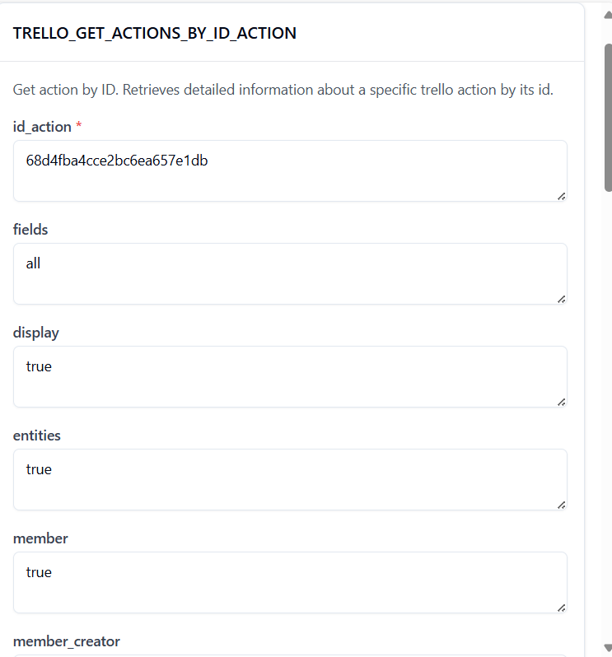

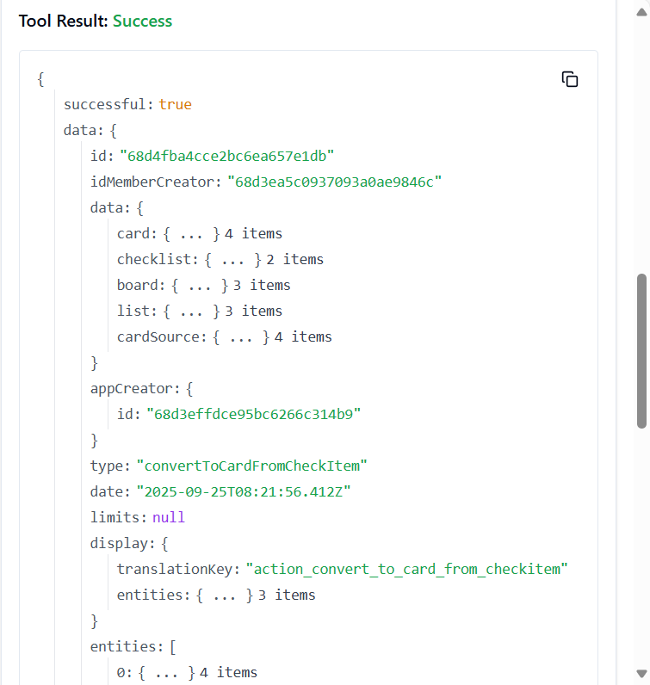

41. **TRELLO_GET_ACTIONS_BY_ID_ACTION_BY_FIELD**

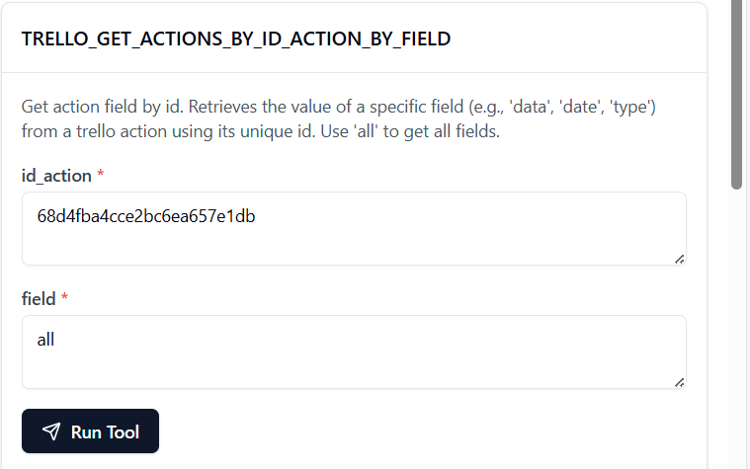

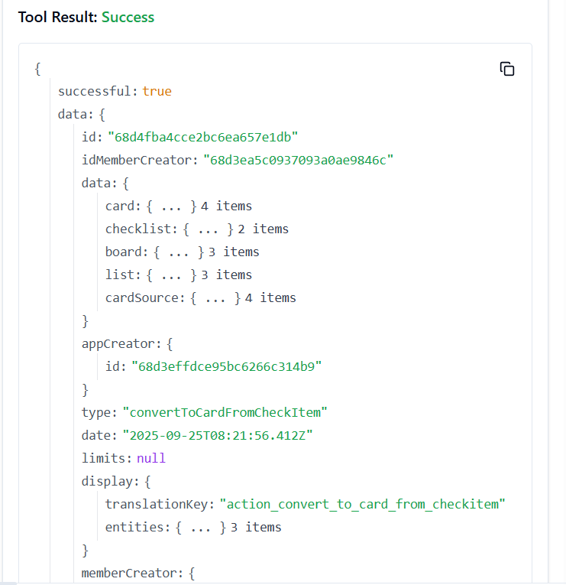

42. **TRELLO_GET_ACTIONS_BY_ID_ACTION**

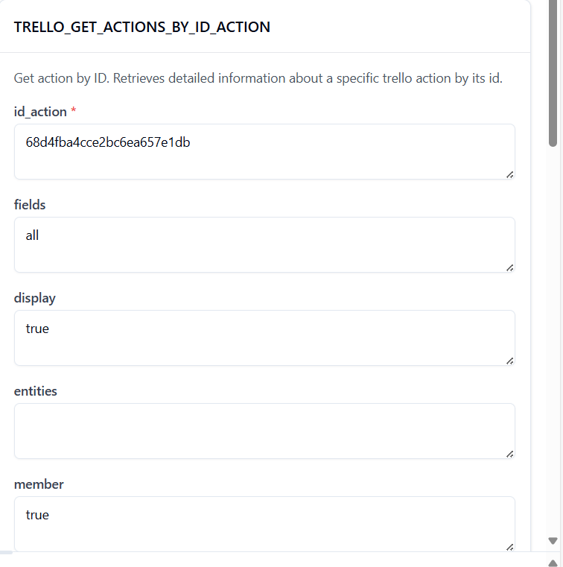

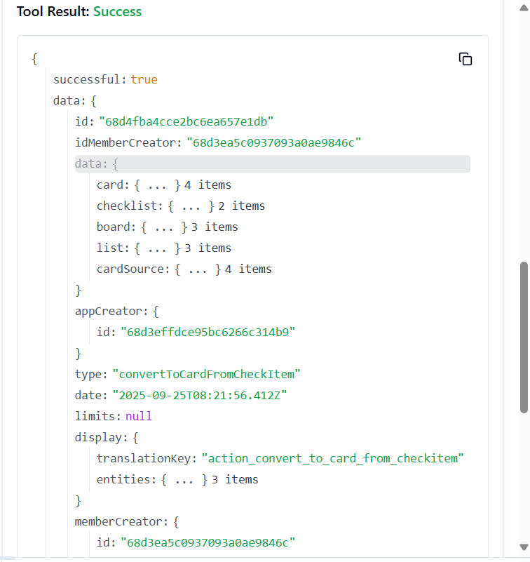

43. **TRELLO_GET_ACTIONS_CARD_BY_ID_ACTION_BY_FIELD**

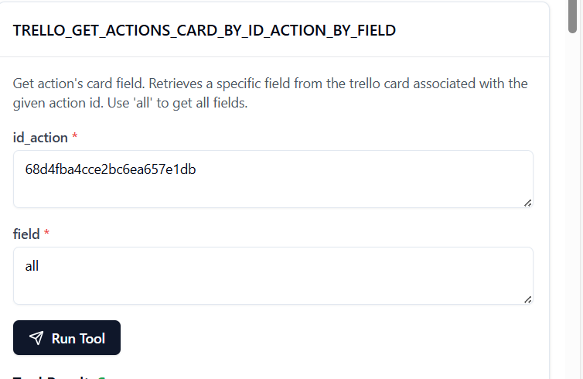

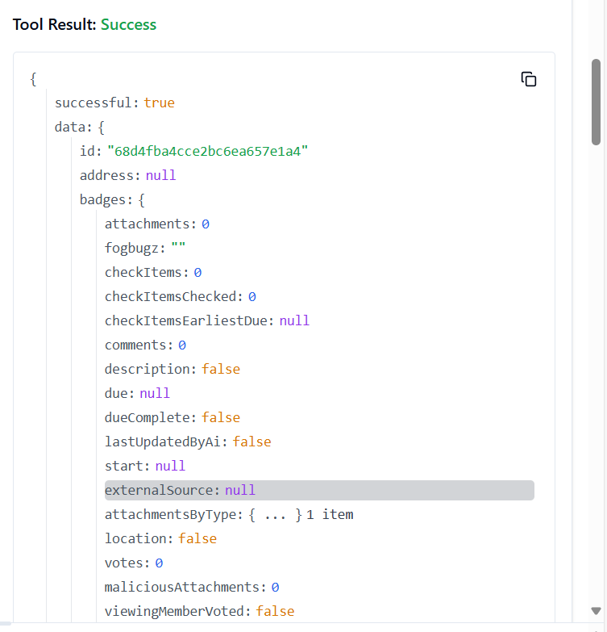

44. **TRELLO_GET_ACTIONS_DISPLAY_BY_ID_ACTION**

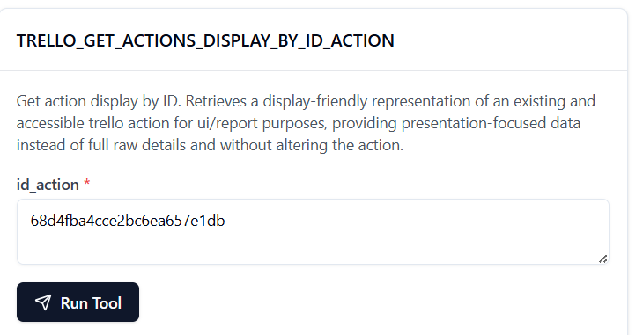

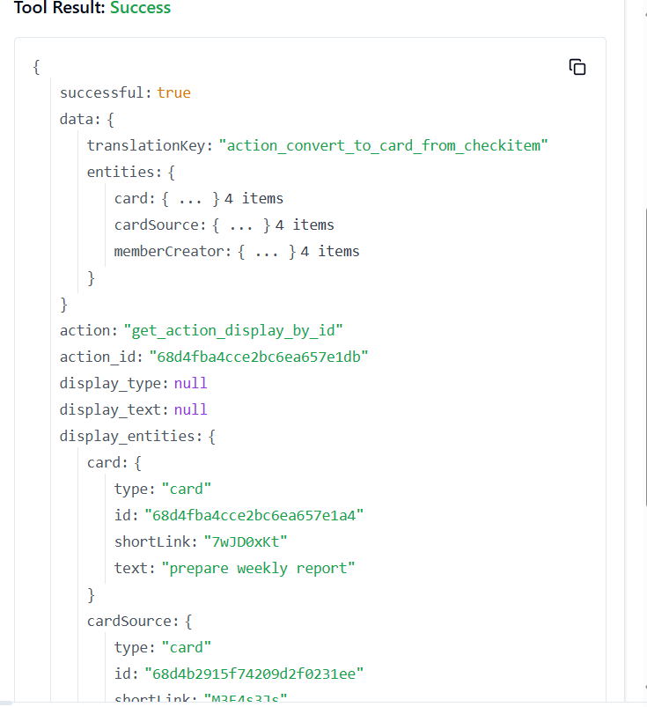

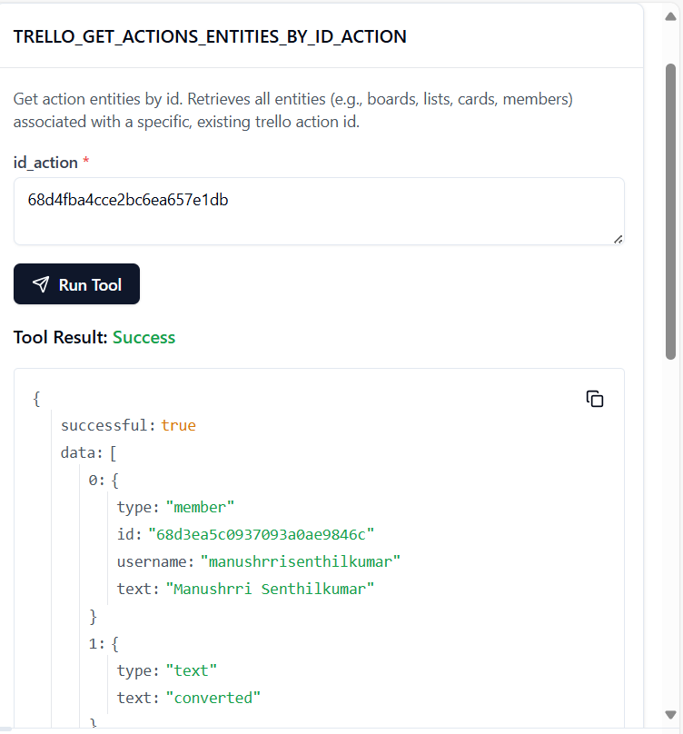45. **TRELLO_GET_ACTIONS_ENTITIES_BY_ID_ACTION**

46. **TRELLO_GET_ACTIONS_LIST_BY_ID_ACTION**

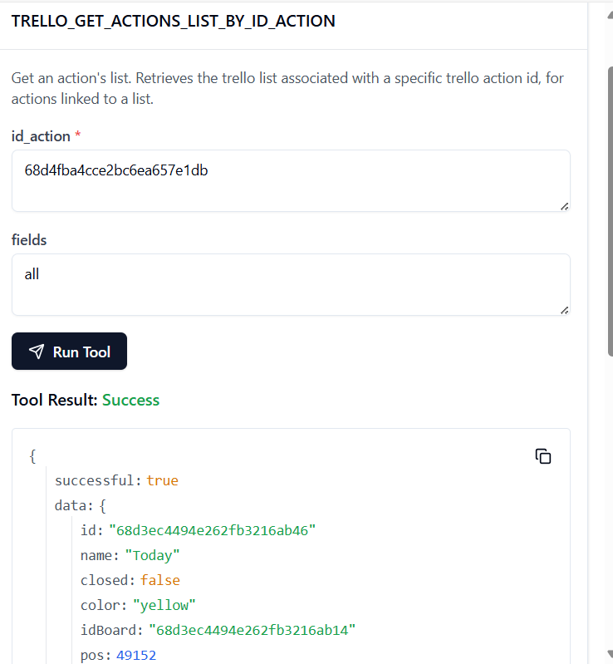

47. **TRELLO_GET_ACTIONS_LIST_BY_ID_ACTION_BY_FIELD**

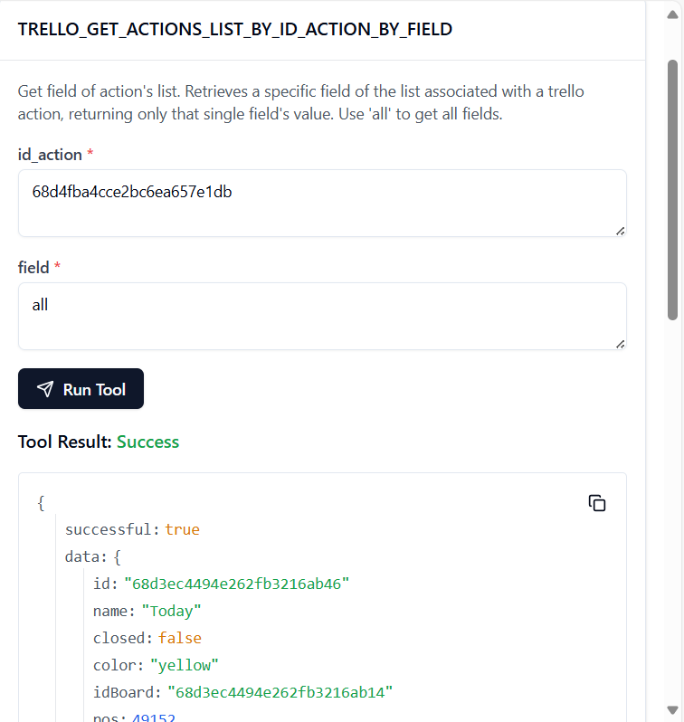

48. **TRELLO_GET_ACTIONS_MEMBER_BY_ID_ACTION**

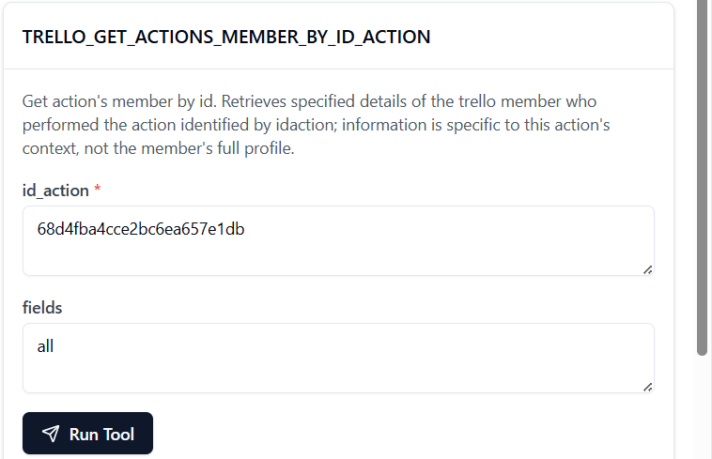

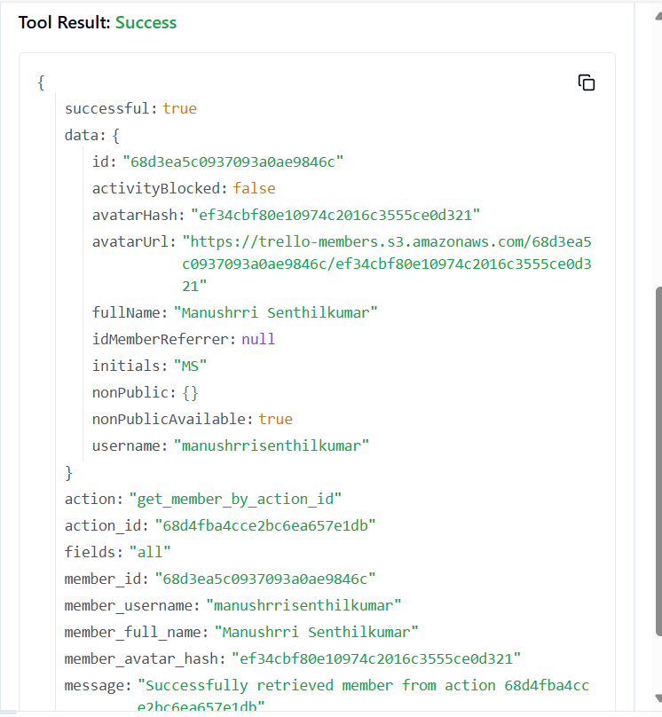

49. **TRELLO_GET_ACTIONS_MEMBER_BY_ID_ACTION_BY_FIELD**

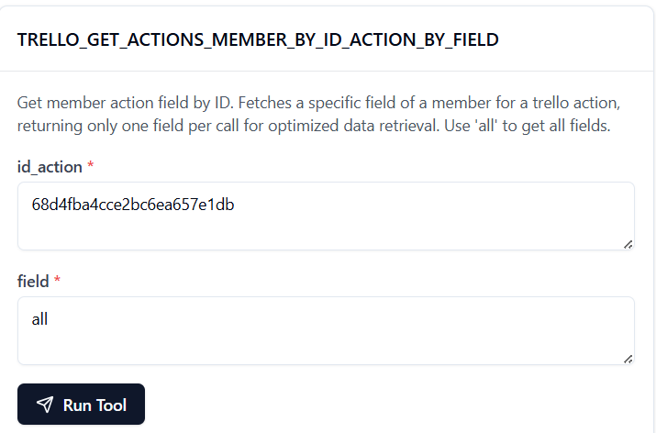

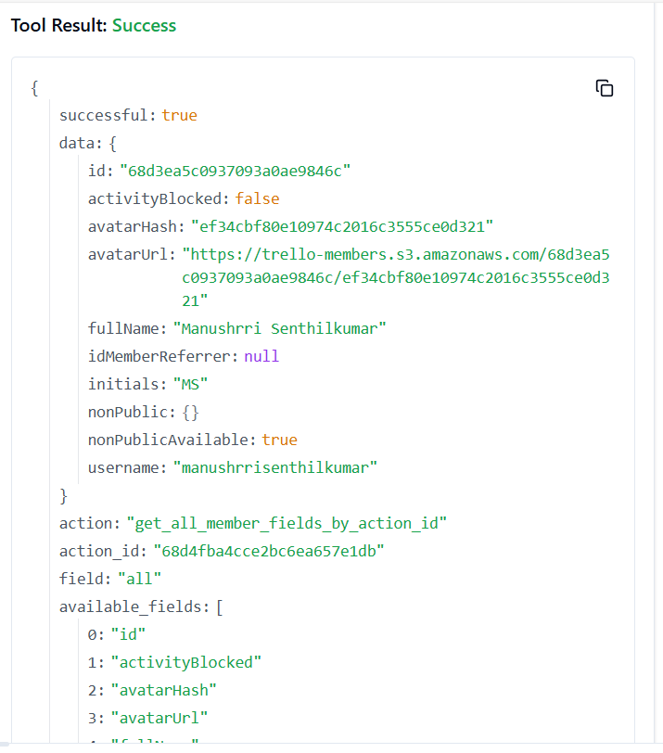

50. **TRELLO_GET_ACTIONS_MEMBER_CREATOR_BY_ID_ACTION**

